Thomas Baugh, Elsa Casey, Malora Huggins, Joel Windsor
Completed on February 17, 2014
As Assignment 5.2 of MU 589 – Music Technology Pedagogy
Facilitated by Dr. Lee Welch, Instructed by Dr. Jay Dorfman
Spring Online Session I, 2014 at Boston University
The Music Interactive
Heuristical Analysis of Music Education Applications

The Music Interactive is a website that distributes several music instructional applications. The target audiences for the applications range from elementary school to advancing musicians. Marc Jacoby and Craig Jonci created the website “as a vehicle to distribute music learning activities and games that cover a broad range of uses in both classroom and performance based environments.” (The Music Interactive, n.d.)
Four of the applications offered by The Music Interactive have been analyzed according to the outline for heuristic analysis provided by Reeves et. al. (2002). To get a clear understanding of common characteristics of applications offered by The Music Interactive, this group selected four applications from the list of twenty offered by the website. As the majority of the applications on the website were offered under a “Classroom Apps” heading, we chose to evaluate three of the applications from that list; JamaMambo, Recorder, and Staff Wars. The fourth application we evaluated came from the “Performance Apps” category, titled “Sheddin’ Jazz Piano”. It should be noted that the Staff Wars application was experienced on an iPad, and is not the “Staff Wars v2” option also offered by The Music Interactive. The other three applications were experienced on both Windows and Macintosh computers. Each application was analyzed by an individual, and the final collaboration was completed via Google Drive and Skype to produce the overall analysis that follows.

Visibility of System Status
All of the applications studied used the operating system’s installation tools, and so the installation procedure was familiar for the user. Each application also had a “startup” screen, or a “splash” screen that either introduced the application or directed the user to make a selection. Such a startup “splash” screen is shown in Appendix 1. No further instructions were given to the user.

Match Between System and The Real World
JamaMambo’s rhythm section allows students at young ages to know how to use the software. The Staff Wars game was user-friendly to the students who already knew the note names. Level of difficulty in both applications increased rapidly, therefore, it would not be suitable for a beginning student. The instructions are easily accessible, but the applications are also simple enough to understand the final goal without the instructions.
All terminology used in the application, such as “comping” and “voice leading”, is common to the jazz genre. Even the title “Sheddin’ Jazz Piano” refers to a commonly understood phrase referring to extensive jazz practice, “woodshedding”. In terms of the user interface, it too matches the real world in many ways; the playback/recording controls are clearly marked and use common symbols, with only the absence of the fast-forward or rewind options, which could have been useful additions. The use of the term “Session” misleads the user to believing they should be able to complete the content in a single sitting, when in fact there are 5 to 8 lessons within each “Session”.
The Recorder application, opens with an image of a music stand as the backdrop for the software (see Appendix 2). This makes the connection that the student is reading the music as they would if it were real sheet music. There are 4 clickable areas on the stand that provide access to different aspects of the software using an “On/Off” style of interaction. Each of the items, “Fingering Chart”, “Melody”, “Notation”, and “Drag Fingerings” match vocabulary with the lessons that utilize the recorder. There are also “Stop”, “Play”, and “Play with Notes” buttons for use with the Drop-down menu of songs.

Error Recovery and Exiting
In JamaMambo, if a student or instructor wants to leave the application immediately, it can be easily done. The Quit button is located in the right corner. The application also allows the student or teacher to make sure they want to quit the software. If it is a mistake, then they can easily return to where they were in the application.
It is easy to exit the Staff Wars game by pressing quit and returning to the main menu. You can not quit in the middle of a game but had to keep playing until you have three errors. Then, the screen says, “game over.” If you want to quit in the middle of the game, you must exit the application. It then allows you to enter the software again and start where you left off.
All input for this application is done via a MIDI keyboard. As the MIDI keyboard can sometimes have a delay, the user’s recording and the exemplar may be slightly shifted from each other in the playback. Some of the practice modules do not bring up the entire prompt, leaving the user guessing as to which chords and scales they are supposed to be rehearsing, as shown in Appendix 3. Another issue in the software is that the “Pianists” section of the “Appendix” caused a fatal error for the application, and when such an error occurs the computer’s operating system simply force-closes the entire application. Throughout the application, a button in the top-left corner takes you away from the current application all the way out to the “Quit” option to completely exit the application.
Since the Recorder application is designed mostly for playing practice, there isn’t a way to do any error recovery other than restarting the song. In the composition and “Drag Fingerings” part of the software, there is a clear Undo link and Reset link to make sure that mistakes can be erased. To exit the application, the user simply needs to close the window as there is no exit/quit command that is clickable.

Consistency and Standards
Both JamaMambo and Staff Wars adhered to what one would expect to see when playing a video game with terminology like “correct”, “game over”, and “select your mission” as well as goals that would advance you to the next level. Both games advanced quickly through the levels.
Similarly Sheddin’ Jazz Piano was set up in a more stand-alone environment, however not as a video game. The software was originally designed to be distributed on a CD-ROM, and therefore employs it’s own methods for interacting with the software. When choosing which module, or “Session” to open, the list of lessons inside that module appear, suggesting to any user who is used to the idea of “drop-down menus” on a website to move their mouse over those lessons, only to find that in order to access those lessons they must click on the module name first.
The Recorder application uses an On/Off clickable link in order to go from one part of the application to the other. When a link is clicked, it opens that aspect of the software, and the other links disappear. In order to go back to the main screen, you must click the same link again. The use of the “drop-down” menu for song choice and the “Stop”, “Play”, and “Play with Notes” buttons are done with standard icons to be easily understood.

Error Prevention
With JamaMambo, Staff Wars, and Recorder, there was no possibility for a bad input on the part of the user. You either clicked (or if using an iPad on Staff Wars, touched) something on the game or you didn’t. The Recorder application is a tool for practice, and not designed as a stand-alone teaching tool.
With Sheddin’ Jazz Piano, the inclusion of the MIDI keyboard added an extra challenge. If you tried to operate the application without a MIDI keyboard attached, it did not warn you that there was no keyboard attached even though it was required to interact with the application. If you were in need of assistance in setting up the MIDI keyboard, there was no help provided by Sheddin’ Jazz Piano to set that up.

Navigation
A user of any of the studied applications should be able to navigate the application with no problems. JamaMambo allows a person to easily find instructions, the ability to try again, add a metronome, or to quit the application. No errors occur while playing the Staff Wars game and navigating among the screens was simple. All modules or lessons of a module in Sheddin’ Jazz Piano are accessible by the “keyboard menu” on the left of the screen, and once inside a specific lesson, it is easily determined how to “flip” through the pages of that lesson. The Recorder application is perhaps the only one with slightly challenging navigations, as the user has to navigate away from the music in order to check a fingering, only to restart the entire song from the beginning when they return.

Aesthetics
JamaMambo is appealing to the eye with the main character being Sammy The Frog. However, the picture of the frog immediately draws attention to the younger students.
Staff Wars is designed to appeal to people who enjoy video games. It had explosive sound effects when the spacecraft’s weaponry shot at a note. It is reminiscent of a retro Star Wars video game. The words “Select your mission” can be difficult to read on the dark background.
Font choices can be slightly distracting in the introductory screen of Sheddin’ Jazz Piano, but all following fonts match Jazz Font standards. The colors of the screen are intuitive, highlighting what needs to be highlighted, and not distracting from the learning environment. The introductory and exit “splash” screens are accompanied by unnecessary noises for the brands that appear, but otherwise the look and feel of the software matches that expected in an interactive learning environment.
The Recorder application uses good font choices, but the colors chosen can be dark if using them with a projector. One feature is the “Play with Notes” where the software will highlight the note that is being played the color yellow (versus black) so that the student can recognize and follow where the playback is visually. The “Melody On/Off” button turns on and off the playing of the melody during playback, allowing the student to either try and play with the recording or as a solo.

Help and Documentation
All extra documentation for any of the applications studied, and any others included on The Music Interactive website are of course found on that website. These resources are updated very regularly. The developers are also very easily contacted by way of the website.
JamaMambo and Staff Wars allow the user the ability to find a list of instructions; in JamaMambo access to these instructions were in the top left hand corner, in Staff Wars they were in the lower left hand corner. This can be found when the application is opened. It would have been nice to have a “training mode” in which the correct answers could have been given when the student made errors.
With Sheddin’ Jazz Piano and the Recorder application, no help files nor documentation were provided. It is possible that this is done due to the ease and intuitivity of the software, and the fact that the majority of the interaction with the application is experimental and experiential.

Interactivity
Students can easily start JamaMambo without much instruction. In JamaMambo, it is an excellent rhythm and drill practice for elementary students. It allows the students to see and hear a rhythm. Sammy The Frog performs the rhythm and the user chooses the correct answer from three choices. The goal is fulfilled by filling up the jar with ten correct answers.
The user can also start Staff Wars with minimal instruction. It is a note-naming drill and practice application targeting middle school students. The task of “shooting” the notes on the staff motivates the student to drill and practice the note names on three different staves.
The emphasis of Sheddin’ Jazz Piano is on performing and listening. Any text provided is accompanied by written examples, listening examples, and opportunities to practice extensively. It is even possible for users with piano and music theory experience avoid the text and go straight to the practice without having lost any learning opportunities. Students can practice from slow to fast, and can advance at their own pace or desire. This can be an advantage, but the content of the application is scaffolded well, so students who purposefully skip a lesson will either have developed those skipped skills outside the software or feel a lack of confidence in their performing abilities.
The Recorder application’s main focus is on aural listening and practicing with background for performance. There is a simple, two measure compositional application that uses both drag-and-drop and click-to-add aspects and includes playable backgrounds. The only other interactive aspect is a fingering chart that students or the teacher can use to look at and create patterns for practice.

Message Design
Sammy The Frog is excellent to grab the students’ attention for late elementary students. Many junior high students find Sammy to be distracting. Therefore, the application is usually more appropriate to late elementary students, but the rhythms are too complex for early elementary.
The “Help” option in Staff Wars, turned out to be very helpful with a paragraph of instructions and a staff with note names. The instructions were in small print and would be better for a middle school student than an elementary student.
The content of Sheddin’ Jazz Piano is not cluttered and flows naturally from left to right, top to bottom. Samples also flow in this same manner, and are presented as focal points of each lesson in the application. All the content is presented one point at a time, and the text clarifies expectations well. Due to the level of difficulty of the content, it is appropriate that there are no extra graphics or audio distractions, as it seems to be geared towards junior high school pianists and older.
The visual design of the Recorder application works very well for the younger students who would be working with recorders in their music classroom. The font of the music is large and clear and the notes used are well spaced for consistent reading. The highlight feature of the melody enhances the reading of the notes for students during playing. There is one distraction that comes in the form of the titles for the songs that move and turn, causing the eye to be drawn to them rather than the music itself.

Learning Design
Once JamaMambo is opened, it is clear that the objective is to learn about rhythms. The illustrations of rhythmic choices at the bottom of the page allow the learner to choose a correct answer. Students that may have more difficulty finding the beats or counting are able to add a metronome to assist them. A teacher could also use the three examples at the bottom of the app to practice counting other rhythms. Students are given a sense of completion through the filling of a jar.
Tasks in Staff Wars are designed to help the student drill note names on the staff. The student would need prior knowledge of the note names in order to play the game successfully. The help screen gives the student a chance to review note names, but would be overwhelming for someone who had no knowledge of the staff.
Each lesson within a module (or “session”) of Sheddin’ Jazz Piano scaffolds well into the following lesson, and each session into the following session. The learning objectives are explicitly stated at the beginning of each lesson, and the practice options between each lesson enhance the learning well.
The theory behind the construction of the Recorder application is one that is used in music classrooms on a consistent basis. Since listening is a vital aspect of music education, the ability to turn on and off the melody playing and then adding background choices allows for differing skill levels to be able to utilize the same materials.

Media Integration
If a teacher is beginning instruction on rhythms, JamaMambo is great to use for late elementary because of the application design. Many students will listen better if someone or something impractical is doing the speaking. Sammy The Frog is a perfect example of this situation. The inclusion of this character engages students so that they are willing to experience more complicated rhythms.
Staff Wars, however, had little to no media integration with the exception of the staff lines on the screen. Students interacted with the visuals, but upon clicking the correct pitches it did not play them back for the user. In this way, the application could have included more musical interaction. The only other media inclusion was the Muzak in the background. It should be noted that a MIDI keyboard is integrated into the new iteration of “Staff Wars” on The Music Interactive website called “Staff Wars v2”.
Sheddin’ Jazz Piano assumes the computer that it resides on is connected properly to a MIDI keyboard. When this is not the case, the application provides no support to correct the situation. However, should the MIDI keyboard be working, it is perfectly integrated into the application such that the user can hear comparison of their own work alongside the exemplar or simultaneously with the exemplar.
Each song that is available in the Recorder application has a background that plays with the melody in order to enhance the performance of the student. There are backgrounds that can match the style of the original song or be a completely different style in order to explore the way that sound interacts. One thing that is missing is playback of only the melody, all songs must use the backgrounds.

Instructional Assessment
A common issue across all the applications from The Music Interactive is that there is no opportunity for formal assessment built into the applications. In order to develop a formal assessment tool, an instructor would need to do so outside the application environment.
JamaMambo does not have levels of difficulty, which may limit the ability to assess a student’s advancement. As students are often motivated by advancing through levels, it would have been beneficial to include varying levels of difficulty. Levels of difficulty exist in Staff Wars, however the only assessment of student success is how many correct identifications the student made. A percentage score or list of notes not identified correctly would have been helpful.
As both Sheddin’ Jazz Piano and Recorder are practice applications, self-assessments are completed informally by the user by comparing their own recordings against the provided exemplars. If the user has not been trained to hear when a difference occurs, or if the recording of the user is not synchronized with the exemplar (which can happen especially in Sheddin’ Jazz Piano due to the latency in the MIDI connection to the keyboard), then the user will not be able to self-assess accurately. Feedback is not provided by the application, however opportunities for higher order learning, namely analysis and synthesis, are possible if implemented using teacher or peer interactions.

Resources
There were no additional resources for JamaMambo nor for Staff Wars. All information could be found in the help options in each application. The Recorder application also does not provide any additional resources beyond the playable backgrounds and fingering charts.
The main resources in Sheddin’ Jazz Piano are samples in the lesson text and the exemplar for each practice lesson. As jazz is largely a genre taught by rote, such resources become invaluable. Further, there is a textbook available that links to the application, but the content of the textbook is the same as that of the application, but without the samples or exemplar recordings. There is an appendix section which provides a quick reference for chord symbols and alterations to chord symbols. The “Pianists” section of the appendix caused the application to crash, as discussed previously under “Error Recovery and Exiting”.

Feedback
Feedback in both JamaMambo and Staff Wars is based on how many note names or rhythms the user selects correctly. In JamaMambo, the student is successful if they answer correctly within a given time, whereas in Staff Wars the difficulty level increases as the student succeeds.
Both the Sheddin’ Jazz Piano and Recorder applications do not provide any formalized feedback whatsoever. Any feedback a user receives has to be sought out by the user through recording their own efforts and playing them back and self-assessing. Further, they do not provide any indication to the user as to their advancement or progress. A technology-based music instructor may be able to integrate this application with a recording software such as Audacity to collect student recordings and provide feedback, but this all happens outside the application environment.

Summary
With the assumption that each of these applications are good exemplars of all applications hosted by The Music Interactive, they are relatively well-designed engaging tools for teaching various elements of music. The limitation of all these applications is that there are no formalized assessment tools, however, with the focus on specific tasks and the engaging ways in which the user interacts with them, the applications can easily enhance the musical learning of their target audiences. The applications would most likely be used in scenarios where the entire class interacts together using a projection system, or where individual students would use them for their own individualized instruction.

Appendices

Appendix 1 - Staff Wars Startup Screen
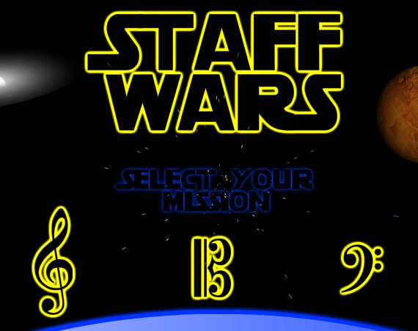

Appendix 2 - Recorder Application Main Page
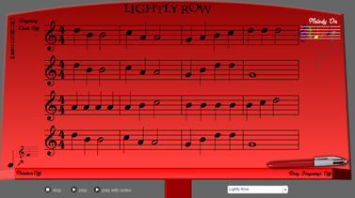

Appendix 3 - Sheddin’ Jazz Piano Screen with Errors
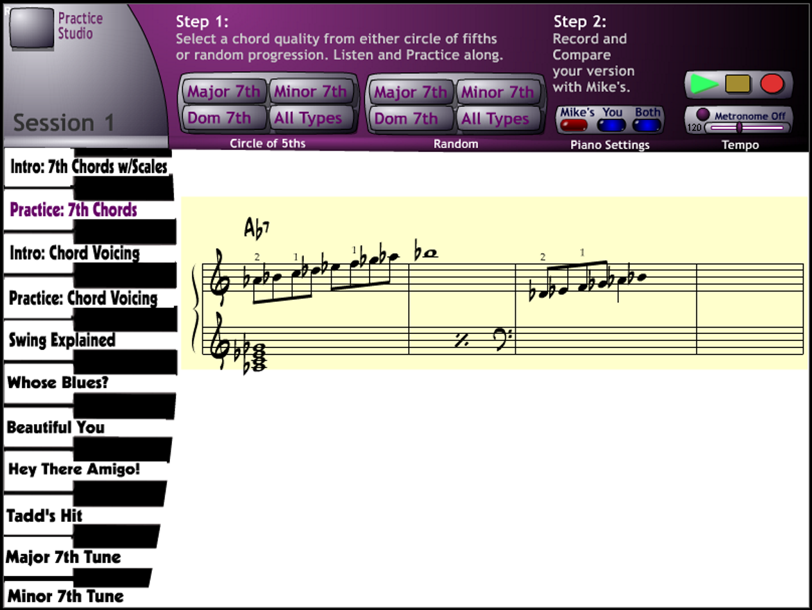

References
Reeves, T. C., Benson, L., Elliott, D., Grant, M. Holschuh, D. Kim, B., et al. (2002). Usability and instructional design heuristics for e-learning evaluation. Paper presented at the ED-MEDIA World Conference on Educational Multimedia, Hypermedia & Telecommunications, Denver, CO.
The Music Interactive. (n.d.). Retrieved February 17, 2014, from http://www.themusicinteractive.com/TMI/about.html

